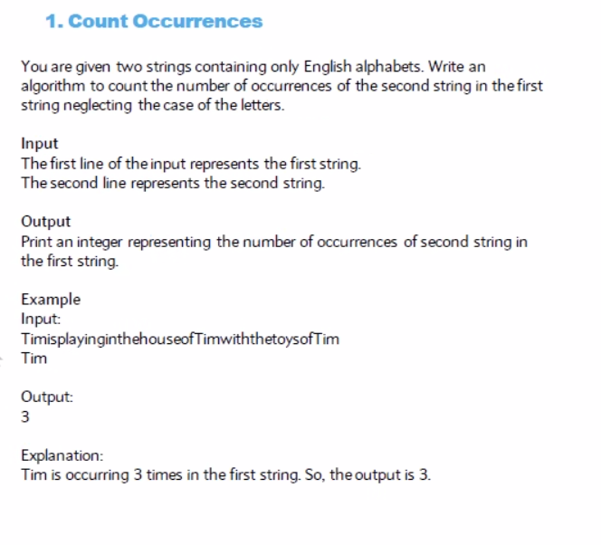

def func(s1, s2) :

if len(s2)>len(s1):

return 0

count=0

for i in range(len(s1)-len(s2)+1):

if s1[i:(i+len(s2))] == s2:

count+=1

return count

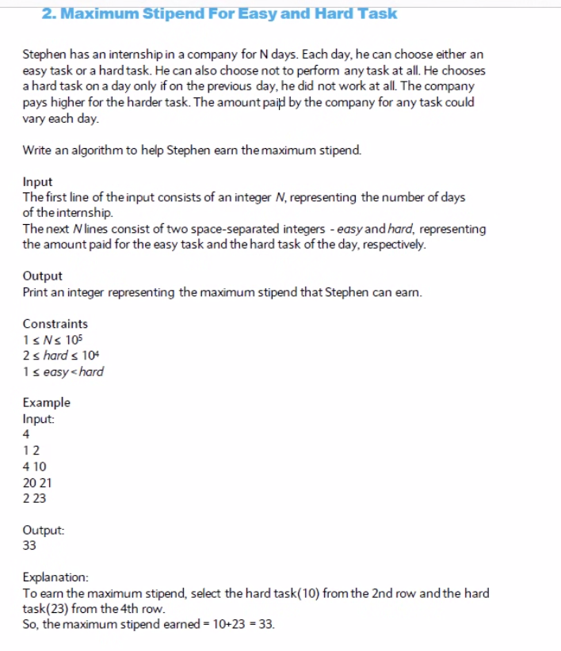

Hard task: not working before

def func(N, L):

count= L[i][2]

temp= L[i][2]

for i in range (1, N):

if L[i][2]> L[i][1] + temp:

temp= L[i][2]

count+= L[i][2]- temp

else:

temp= L[i][1]

count+= L[i][1]

return count

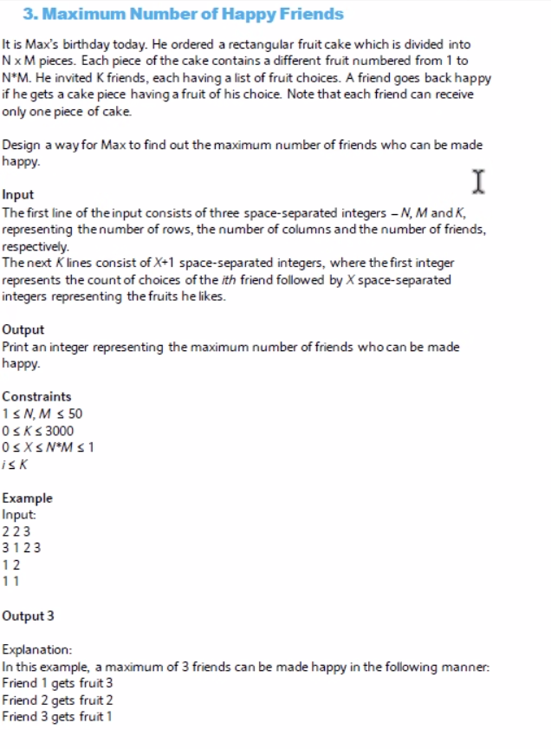

Def(N,M,K, L):

Dictionary with k is the label of the fruit and value is the number of people who likes this fruit.

K!

For

K! \* K \* (N\*M)